**Software Engineering Tools Lab**

**Assignment No-4**

(Module 4- Configuration management tools)

**PRN: 2019BTECS00017**

**Full name: Muskan Raju Attar**

**Batch: T1**

**Q 1. Differentiate Chef Vs Puppet Vs Ansible Vs Saltstack w.r.t properties given below**

1. **Owner/ Company**
2. **Open/free/proprietary**
3. **Size**
4. **Configuration type(push/pull)**
5. **Components**
6. **Written in language**
7. **Tasks that can be performed (infrastructure/code management etc.)**
8. **Advantages**
9. **Disadvantages**
10. **Website**
11. **Installation prerequisite**

|  |  |  |  |  |
| --- | --- | --- | --- | --- |
| Property | Chef | Puppet | Ansible | Saltstack |
| Owner/  Company | Orion  Lab | puppet | Red hat | Salt |
| Open/free  Proprietary | Open source | Proprietary  Close source | Open source | Open source |
| Size | 0.08 mb | 0.08 mb | 0.08 mb | 0.08 mb |
| Configuration  Type(push/pull) | Pull  Push both | Both | Both | Both |
| Components | Workstation,  Server, Node | Puppet master  Puppet agent node | Cloud ,CMDB ,  Playbooks, Hosts | Saltmaster, formula, Saltcloud |
| Written  Language | Client : ruby  Server : ruby  and erlang | C++ , Clojure  4.0 onwards Ruby | Python,  Powershell,  Shell, Ruby | Python |
| Task can  performed | Deployment task  In devops | Deployment task  In devops | Deployment task  In devops | Deployment task  In devops |
| Advantages | 1.Manages huge amount node  2.Write once  deploy many times  3.High availability | 1.Reduce downtime  2.Faster deployment  3.Easy automation | 1.Simple to learn  2.Easily understand to  Python  3.No dependency on agents | 1. Flexible  2.Python api  3.Parallel execution |
| Disadvantages | 1.Not good documentation  2.Not easy to learn if you don’t know ruby | 1.Not good documentation  2.Not easy to learn if you don’t know ruby  3.Not suitable for small businesses | 1.Insufficient UI  2.Limited windows  Support  3.Not have experience | 2.Not good UI |
| Website | [www.chef.io](http://www.chef.io) | www.puppet.com | www.ansible.com | saltprojects.io |
| Installation  prerequisite | 4 gb ram | 4 gb ram | 4 gb ram | 4 gb ram |

**Q 2. What are the different flavours of Chef configuration management tool?**

**Answer:**

Chef comes in various flavours, such as Chef Solo, which has no remote server and cookbooks are located on the local site itself. There’s also Hosted Chef, where a Chef server is provided as a service on the cloud. Thus, there is no need to set up a server yourself. If you want traditional Chef architecture, there’s Chef Client/Server. With this flavour, a hosted remote server communicates between the workstation and node. Finally, there is a Private Chef, which is the enterprise version of Chef. With this flavour, the server is hosted within the enterprise infrastructure.

**Q 3. What is Pull and Push configuration?**

**Answer:**

Pull Based Configuration

In this type of configuration management, the nodes pull the configuration information from the server (hence, the name).

A small software (called agent or client) is installed on every node. This agent/client will:

* at regular intervals, get the configuration from the server
* compare the configuration received from the server with the current configuration of the node
* if there is any mis-match, take the steps required to match the configuration of the node with the configuration received from the server.

This means that, its always the agent/client that initiates communication, not the main server. Chef & Puppet are good examples of such configuration management tools.

Push Based Configuration

In this type of configuration management, the main server (where the configuration data is stored) pushes the configuration to the node (hence, the name). So, it is the main server that initiates communication, not the nodes, which means that an agent/client may or may not be installed on each node.

Ansible is an example of a push based configuration management tool that doesn’t need an agent to be installed on the nodes. SaltStack is an example of a push based configuration management tool that needs an agent (minion) to be installed on the nodes. In both cases, it’s the main server that starts the communication and sends the configuration data to the nodes without the nodes asking for it.

**Q 4. What is Playbook and Inventory w.r.t Ansible and recipe and cookbook w.r.t Chef configuration management tool?**

**Answer:**

Ansible Playbook:

Ansible Playbooks offer a repeatable, re-usable, simple configuration management and multi-machine deployment system, one that is well suited to deploying complex applications. If you need to execute a task with Ansible more than once, write a playbook and put it under source control. Then you can use the playbook to push out new configuration or confirm the configuration of remote systems.

Ansible Inventory:

The Ansible inventory file defines the hosts and groups of hosts upon which commands, modules, and tasks in a playbook operate. Ansible works against multiple systems in your infrastructure at the same time. It does this by selecting portions of systems listed in Ansible’s inventory file, which defaults to being saved in the location /etc/ansible/hosts.

Chef Recipe:

Recipes are written in Ruby and contain information about everything needing to be run, changed, or created on a node. Recipes work as a collection of resources determining the configuration or policy of a node (with resources being a configuration element of the recipe).

Chef Cookbook:

Cookbooks are fundamental working units of Chef, which consists of all the details related to working units, having the capability to modify configuration and the state of any system configured as a node on Chef **infrastructure. Cookbooks can perform multiple tasks. Cookbooks contain values about the desired state of node.**

1. Perform below operations on your machine to check **working of Ansible**.
2. Install Ansible
3. Setup an Inventory
4. Create a playbook to install MySQL db on one node.
5. Execute a playbook

Ans:

Steps to execute installation of ansible:

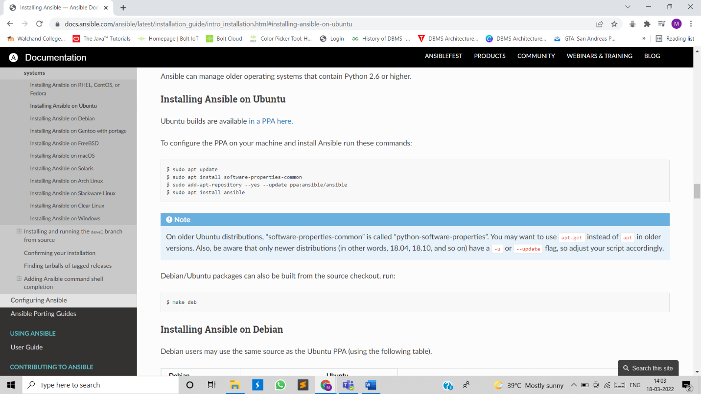

Updating the existing packages:

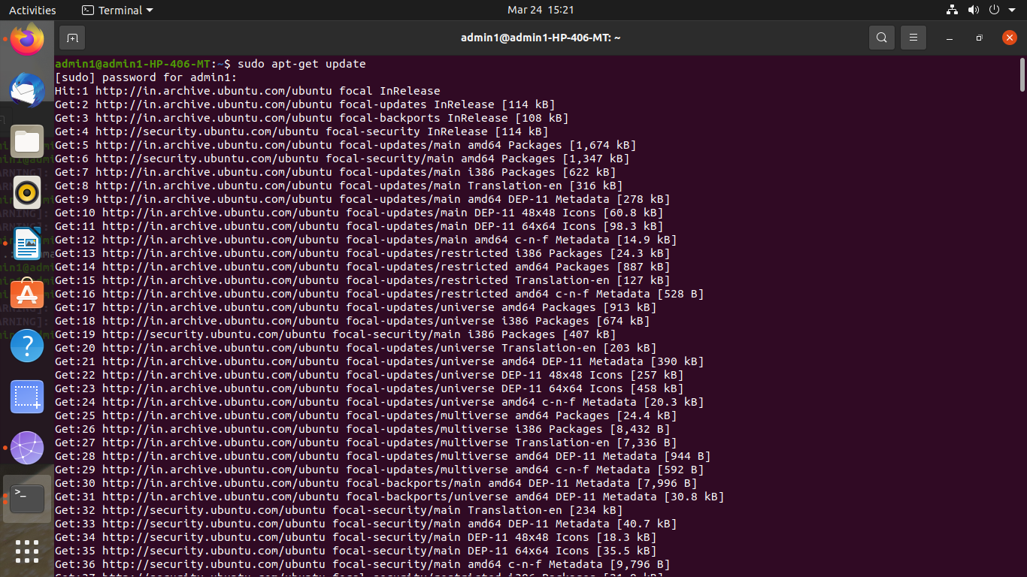

Executed above command to install ansible:

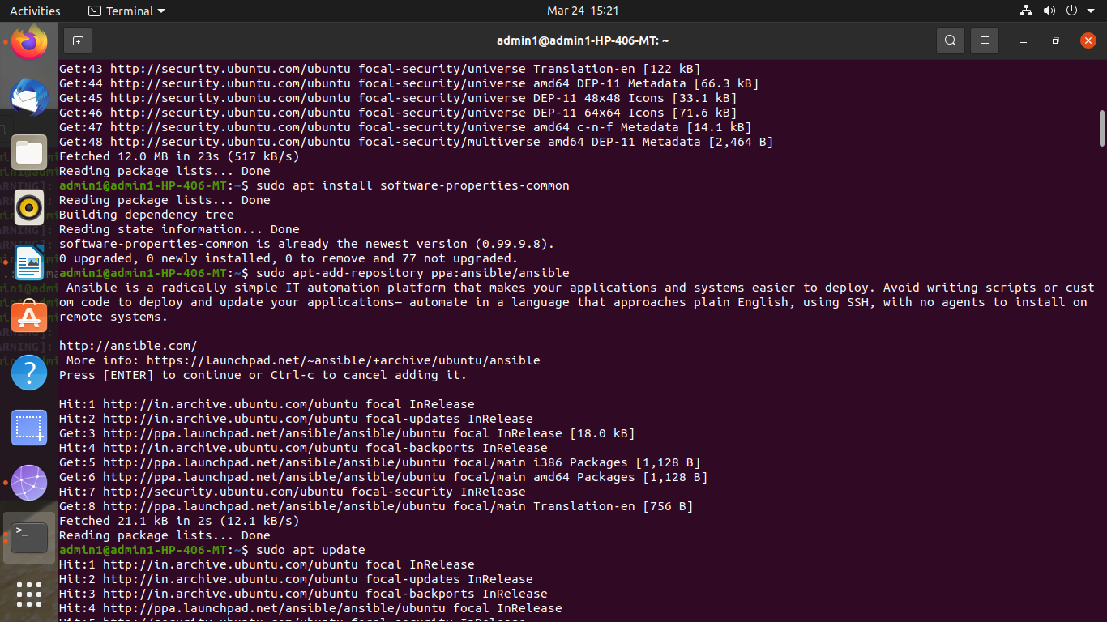

Installation of ssh

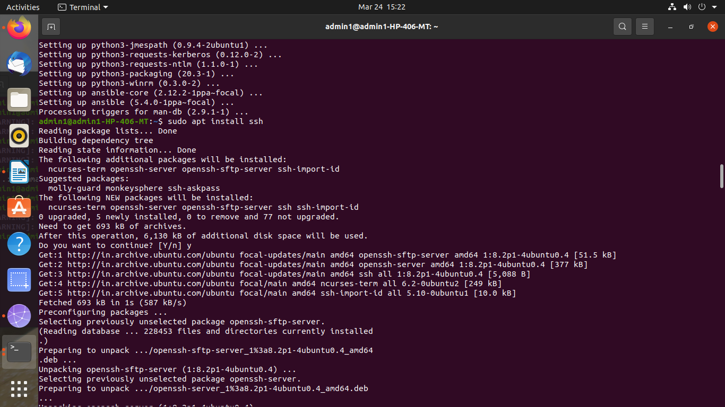

Editing host inventory file, added IP address of working node

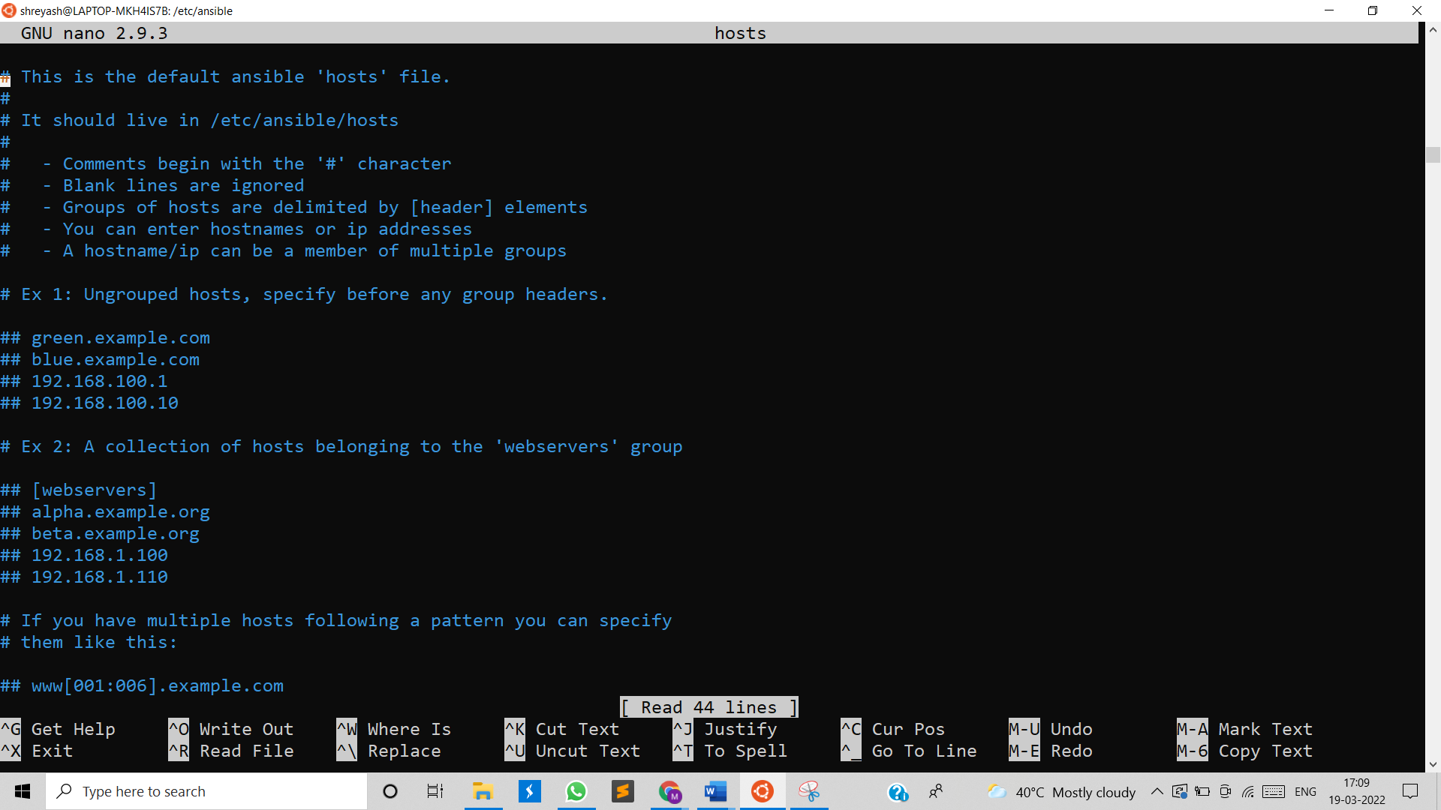

Testing connection with working node

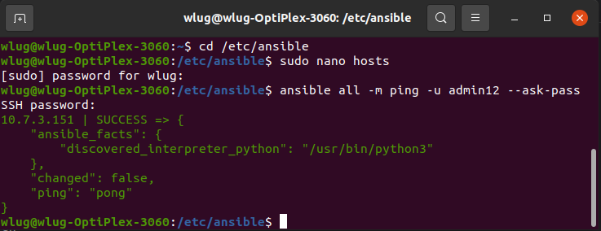

Creating playbook named test.yml file to install MySQL server on that node.

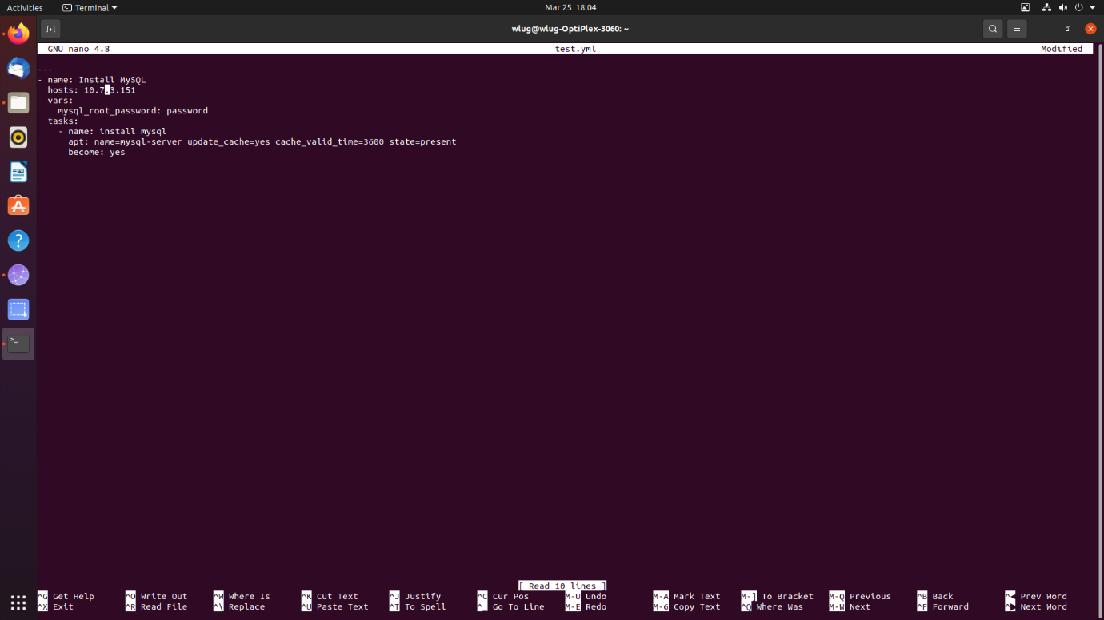

Executed test.yml file for installation.

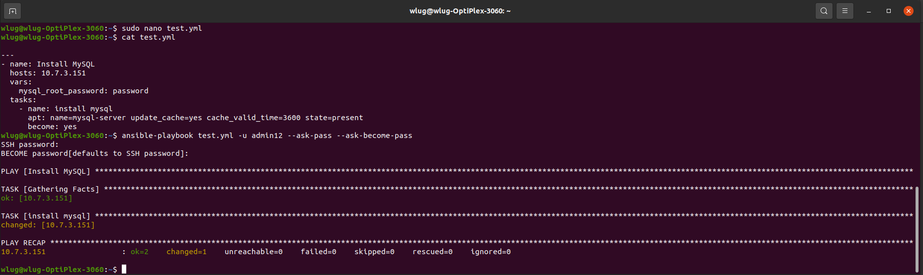

Tested whether the MySQL server installed on node:

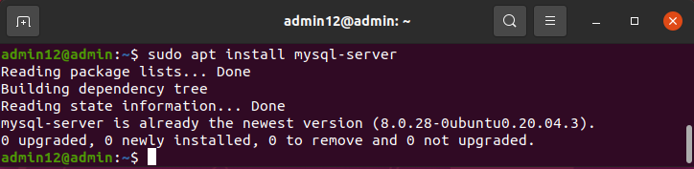

5.Perform below operations on your machine to check **working of Chef**.

* 1. Install Chef
  2. Create a recipe and place it in a cookbook to install MySQL db on one node.
  3. Execute a recipe using knife command.

Ans:

1.Installation of chef-

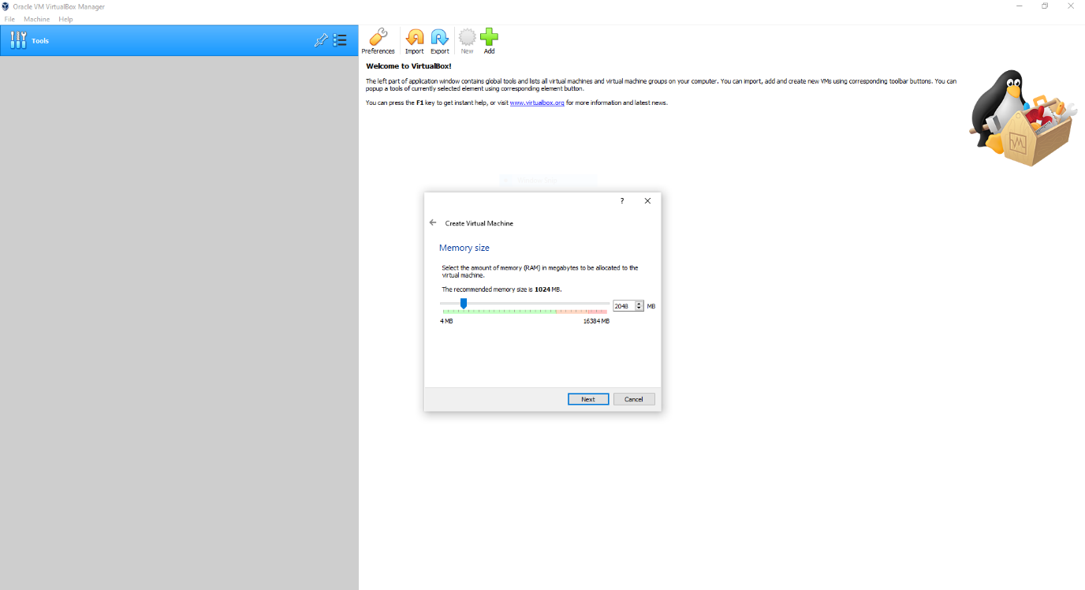

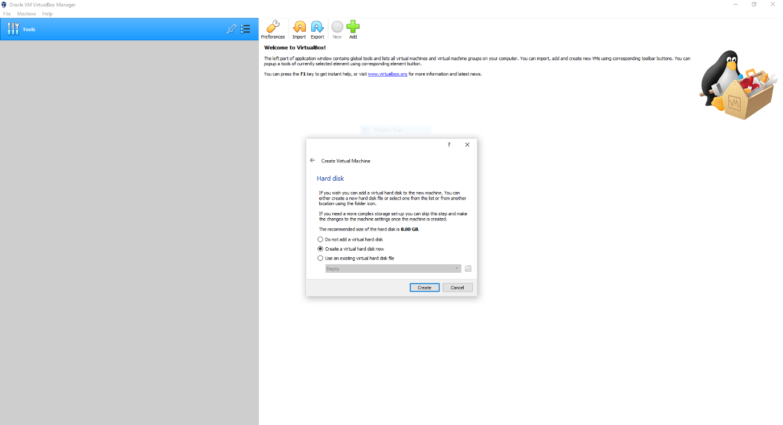

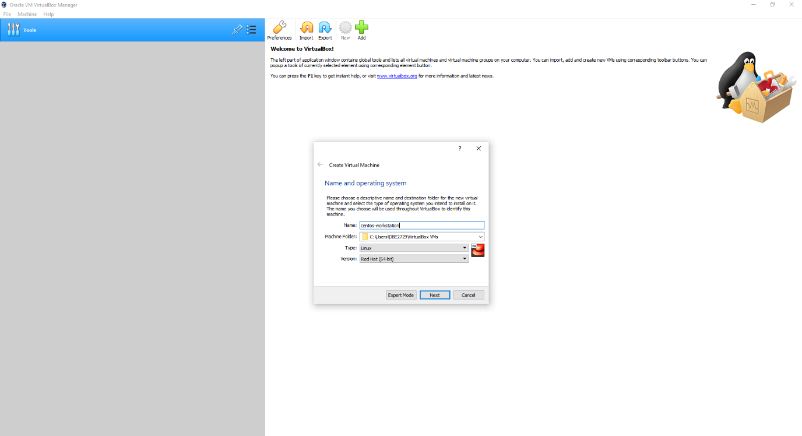

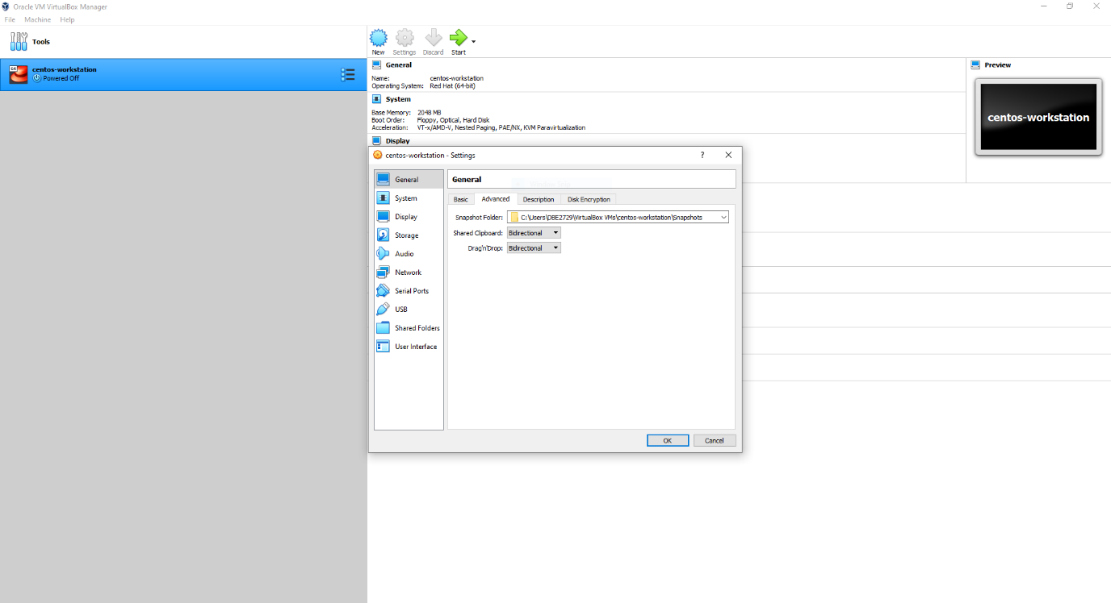

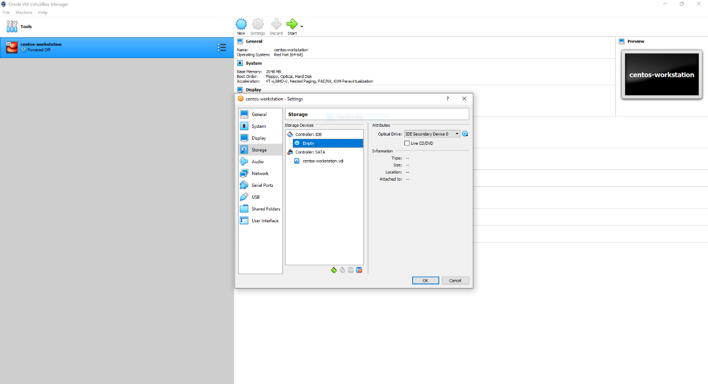

2. Creating a recipe and place it in a cookbook to install MySQL db on one node.

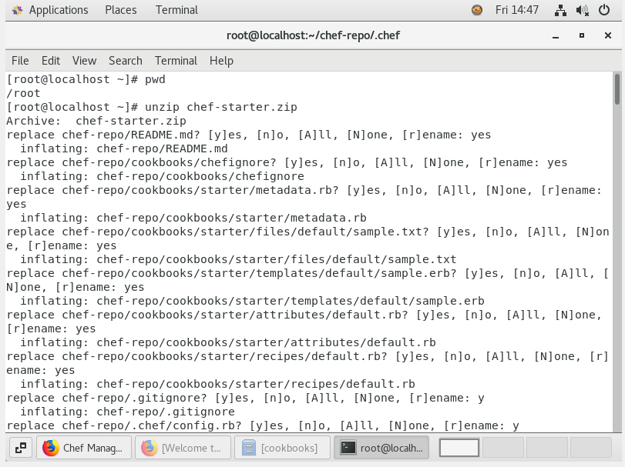

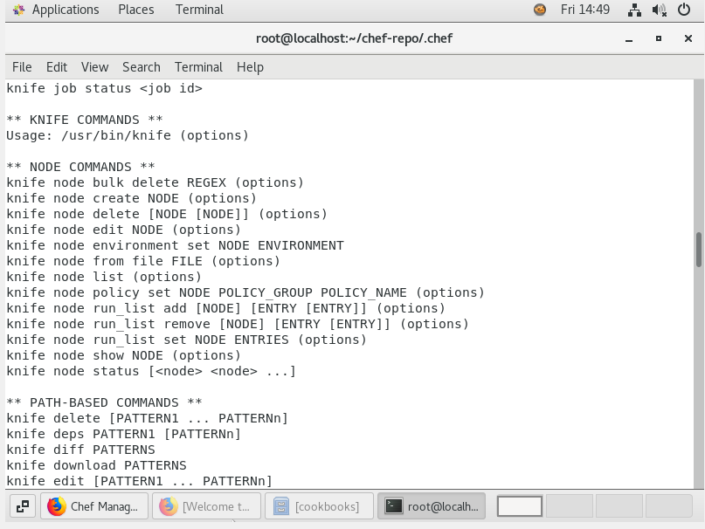

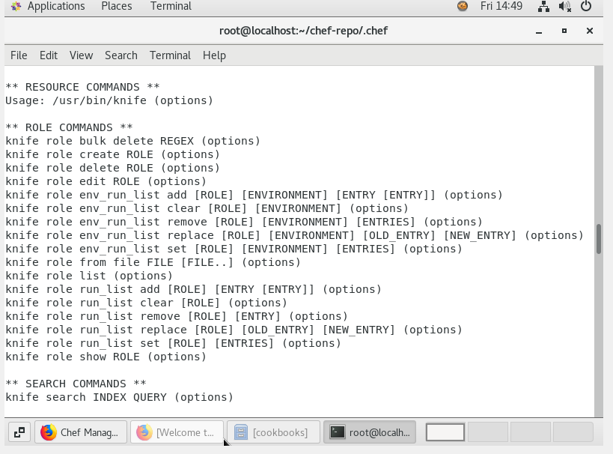

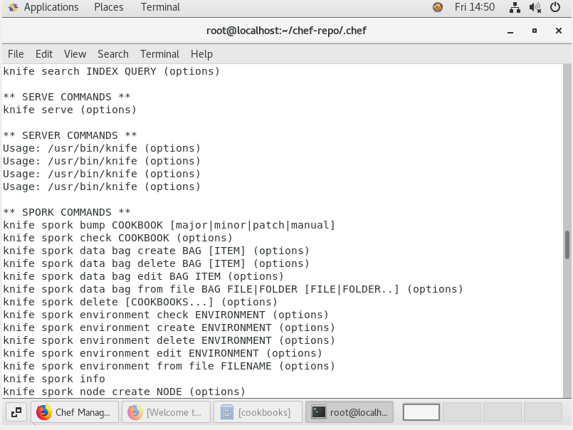

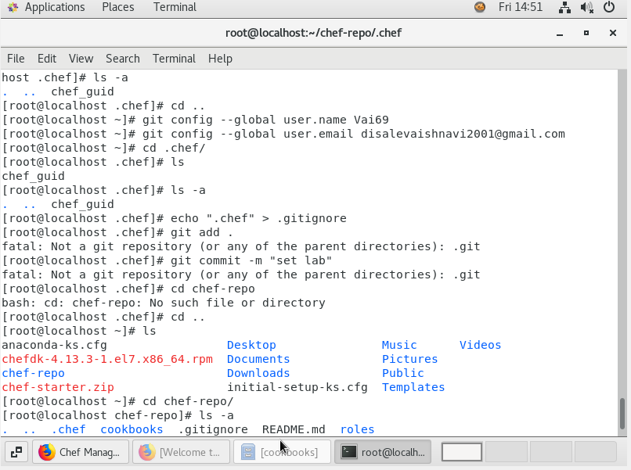

**3.** Executing a recipe using knife command.

